Commodore C64: Kernal64cart Rev. 2
Module description

Introduction
The Kernal64cart is a Kernal cartridge for the Commodore C64, the form factor is identical to the Versa64cart (https://github.com/bwack/Versa64Cart). It fits into the same cases, also the tfw8bit.com stumpy cartridge case (https://www.thefuturewas8bit.com/c64romcart.html).
It allows to select between 8 Kernal images via DIP-switch or jumper.
The $\overline{HIRAM}$signal is required to access the RAM underneath the Kernal ROM (which some software does). This can be connected via a Dupont cable (one wire). Note: it is possible to guess an access to this area of the RAM, but this requires several logic chips or even a CPLD (programmable logic device). This is beyond the focus of this project, which aims at a simple solution, easy and cheap to build.
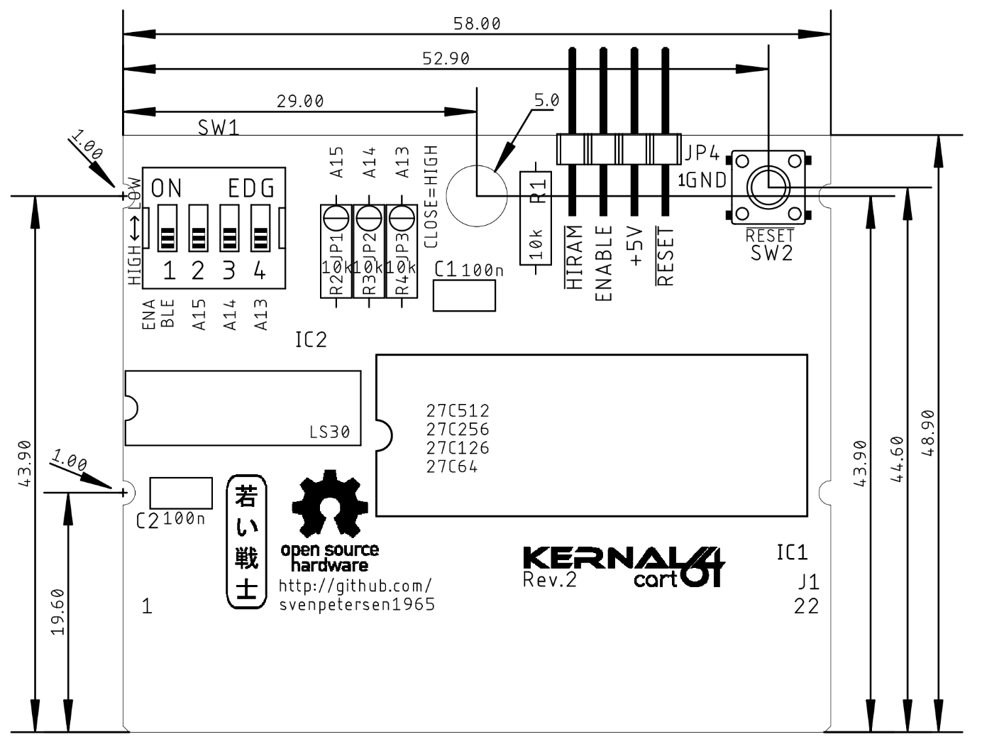
Figure 1: Dimension of the Kernal64cart

DIP-Switch and Jumper Settings

DIP-Switch SW 1
The DIP-switch can enable and disable the Kernal64cart (SW1-1 on/off) and selects the three most sufficient bits for selecting one of the 8 Kernals, that fit into a 27C512 EPROM. The footprint of the DIP-switch allows to use a standard pin header and jumpers or even to select a fix Kernal with solder bridges and also to always enable the cartridge.

DIP-Switch |  |  | Address Bits |  |  | EPROM Address  (Offset)
2 | 3 | 4 | A15 | A14 | A13 | EPROM Address  (Offset)
ON | ON | ON | L | L | L | 0x0000 – 0x1FFF
ON | ON | OFF | L | L | H | 0x2000 – 0x3FFF
ON | OFF | ON | L | H | L | 0x4000 – 0x5FFF
ON | OFF | OFF | L | H | H | 0x6000 – 0x7FFF
OFF | ON | ON | H | L | L | 0x8000 – 0x9FFF
OFF | ON | OFF | H | L | H | 0xA000 – 0xBFFF
OFF | OFF | ON | H | H | L | 0xC000 – 0xDFFF
OFF | OFF | OFF | H | H | H | 0xE000 – 0xFFFF
Table 2: ROM banks

Solder Bridges
Instead of setting jumpers and the DIP-Switch, solder bridges can be utilized to configure the Kernal64Cart. This is an option, in case the configuration of the Kernal64Cart is not prone to be changed. Solder bridges are used to “hard wire” the configuration. The soler bridges withing the footprint of the DIP switch produce a LOW on the corresponding address bit, when they are closed. The solder bridges (JP1, JP2 and JP3) within the footprint of the pull-up resistors R2, R3 and R4 produce a HIGH on the respective address bits in case they are closed. This is not recommended and not required, when the resistors are installed. In case you are not absolutely sure, that you have understood, how it works, install the pull-up resistors and leave JP1..3 open.
Never (!!!!) close both (the LOW and the HIGH) jumpers of one address signal. It cannot be LOW and HIGH at the same time, this will produce a SHORT CIRCUIT of +5V and GND!!!!

EPROMs
Four different types/sizes of EPROMs can be used with the Kernal64Cart, not all settings make sense with them. Their pin out is shown in Table 5.
The effect of the settings and the recommended configurations are shown in Table 6.
27C64
 | 27C128
 |  | 27C256
 |  |  | 27C512
 |  |  |  | SOCKET
Vpp | Vpp | Vpp | A15 | 1 | A15 | VCC | 28 | VCC | VCC | VCC | VCC
A12 | A12 | A12 | A12 | 2 | A12 | A14 | 27 | A14 | A14 | /PGM | /PGM
A7 | A7 | A7 | A7 | 3 | A7 | A13 | 26 | A13 | A13 | A13 | n.c.
A6 | A6 | A6 | A6 | 4 | A6 | A8 | 25 | A8 | A8 | A8 | A8
A5 | A5 | A5 | A5 | 5 | A5 | A9 | 24 | A9 | A9 | A9 | A9
A4 | A4 | A4 | A4 | 6 | A4 | A11 | 23 | A11 | A11 | A11 | A11
A3 | A3 | A3 | A3 | 7 | A3 | /OE | 22 | /G/Vpp | /G | /G | /G
A2 | A2 | A2 | A2 | 8 | A2 | A10 | 21 | A10 | A10 | A10 | A10
A1 | A1 | A1 | A1 | 9 | A1 | GND | 20 | /E | /E | /E | /E
A0 | A0 | A0 | A0 | 10 | A0 | D7 | 19 | D7 | D7 | D7 | D7
D0 | D0 | D0 | D0 | 11 | D0 | D6 | 18 | D6 | D6 | D6 | D6
D1 | D1 | D1 | D1 | 12 | D1 | D5 | 17 | D5 | D5 | D5 | D5
D2 | D2 | D2 | D2 | 13 | D2 | D4 | 16 | D4 | D4 | D4 | D4
GND | GND | GND | GND | 14 | GND | D3 | 15 | D3 | D3 | D3 | D3
Table 5: EPROM pin compatibility
EPROM | Size | A15 | A14 | A13 | 16k
27C512 | 64kx8 | yes | yes | yes | yes
27C256 | 32kx8 | HIGH | yes | yes | yes
27C128 | 16kx8 | HIGH | HIGH | yes | yes
27C64 | 8kx8 | HIGH | HIGH | HIGH | no
Table 6: Settings per EPROM type
In case Vpp is located at a dedicated pin (pin 1), A15 has no effect anymore. A HIGH level is recommended (switch is off) . The /PGM Pin should be set HIGH. The n.c. (not connected) pin should be HIGH (with pull-up) or open. For an 8k EPROM, the 16k setting makes no sense.

Using Parallel EEPROMs
There are parallel EPROMs, which fit into the EPROM sockets. They do not require erasing with a UV eraser, like EPROMs, but the price is higher.
Since they can be written, which is controlled by the $\overline{WE}$signal, but the Super Expander II cartridge is lacking of this functionality, this signal has to be HIGH (inactive). The 28C256 has the A14 signal connected to Pin 1, which is A15 of the EEPROM socket. This is no problem, but it has to be kept in mind, that the jumper for A15 has effect on the bank select A14 of the EPROM.

28C64
 | 28C256
 |  | SOCKET
n.c. | A14 | 1 | A15 | VCC | 28 | VCC | VCC
A12 | A12 | 2 | A12 | A14 | 27 | /WE | /WE
A7 | A7 | 3 | A7 | A13 | 26 | A13 | n.c
A6 | A6 | 4 | A6 | A8 | 25 | A8 | A8
A5 | A5 | 5 | A5 | A9 | 24 | A9 | A9
A4 | A4 | 6 | A4 | A11 | 23 | A11 | A11
A3 | A3 | 7 | A3 | /OE | 22 | /G/Vpp | /OE
A2 | A2 | 8 | A2 | A10 | 21 | A10 | A10
A1 | A1 | 9 | A1 | GND | 20 | /E | /CE
A0 | A0 | 10 | A0 | D7 | 19 | D7 | D7
D0 | D0 | 11 | D0 | D6 | 18 | D6 | D6
D1 | D1 | 12 | D1 | D5 | 17 | D5 | D5
D2 | D2 | 13 | D2 | D4 | 16 | D4 | D4
GND | GND | 14 | GND | D3 | 15 | D3 | D3
Table 7: EEPROM pin compatibility

EEPROM | Size | A15 | A14 | A13
28C256 | 32kx8 | =A14 | OPEN | yes
28C64 | 8kx8 | OPEN | OPEN | OPEN
Table 8: Settings per EEPROM type

Locating the $\overline{HIRAM}$Signal on The Mainboard
The $\overline{HIRAM}$signal is required to be connected for some software to access the RAM below the Kernal ROM. It is an output signal (Pin 28) of the 6510 processor, which connects to the PLA (Pin 7) or the Super-PLA (Rev. 250469 PLA – Pin 6). There are three options to connect the HIRAM signal to a (Dupont) cable:
- Directly soldering the cable to Pin 28 of the 6510 or the respective Pin on the PLA
- Connecting the cable with a test clip to the CPU or the PLA
- Soldering a single Pin (header) to a via of the $\overline{HIRAM}$signal. Those are big enough to hold a 0.65mm sq pin (standard pin header).

Suitable Cases
There are several case options:
- The Versa64case is a 3D-Printed case with a lid. It fits the Kernal64cart with a socketed EPROM
- The Maszczyk KM-20 case (e.g. available from tme.eu) – no EPROM socket possible
- The Kradex Z-7 case (e.g. available from tme.eu) – no EPROM socket possible
- Stumpy cartridge case from https://www.thefuturewas8bit.com/ EPROM on a low profile socket possible.
For the KM-20 and the Z-7, an 3D printed adapter helps to keep the Kernal64cart straight. It is not a requirement, but an elegant way to solve a (minor) problem. The reset button should have a height of 9.5mm for this case.

Revision History

Rev. 0
- Fully functional as a Kernal cartridge.
- The EXROM reset was a misconception, though. The $\overline{GAME}$signal is required to be low for a Kernal cartridge. Having $\overline{GAME}$and $\overline{EXROM}$low at the same time will put the cartridge in the 16k mode and the C64 will “get confused about the Kernals. A PCB revision is required.

Rev. 1
- Fully functional as a Kernal cartridge.
- EXROM-reset removed.
- The Game-stop function, that was “borrowed” from the “REX9628 Extern Kernal” cartridge, which can set $\overline{IRQ}$LOW is not working without software modifications, thus it is not suitable. The feature has to be removed.

Rev. 2
- Fully functional
- Game-stop removed
- Jumper JP4: pinout improved
- DIP-Switch: 4 instead of 5 switches

